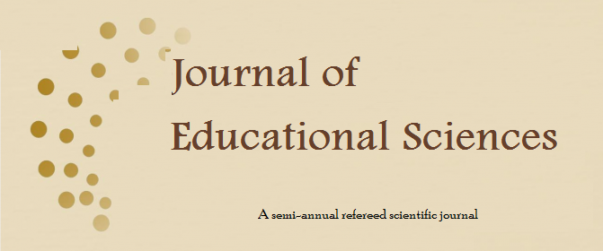

Journal of Educational Sciences: Volume (7), Issue 1442/2021 (2)

Kingdom Saudi Arabia
Ministry of education
Amiri Sattam bin Abdulaziz University

Journal of Educational Sciences
Semi-annual scientific journal
Published by Al-Amri Sattam bin Abdulaziz University

Volume Seven, Issue Two
Dhul-Hijjah 1442 AH / July 2021 AD
RDM: 1567 - 7447

ISSN 1658-7448

URL: http://jes.psau.edu.sa

