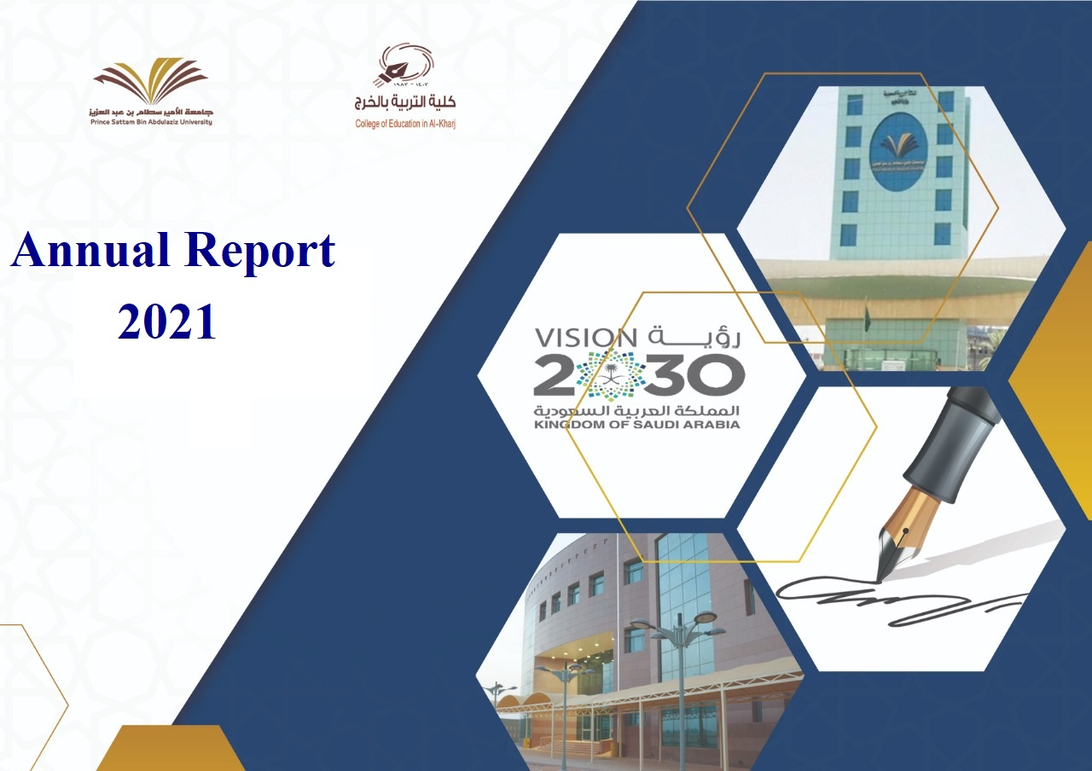

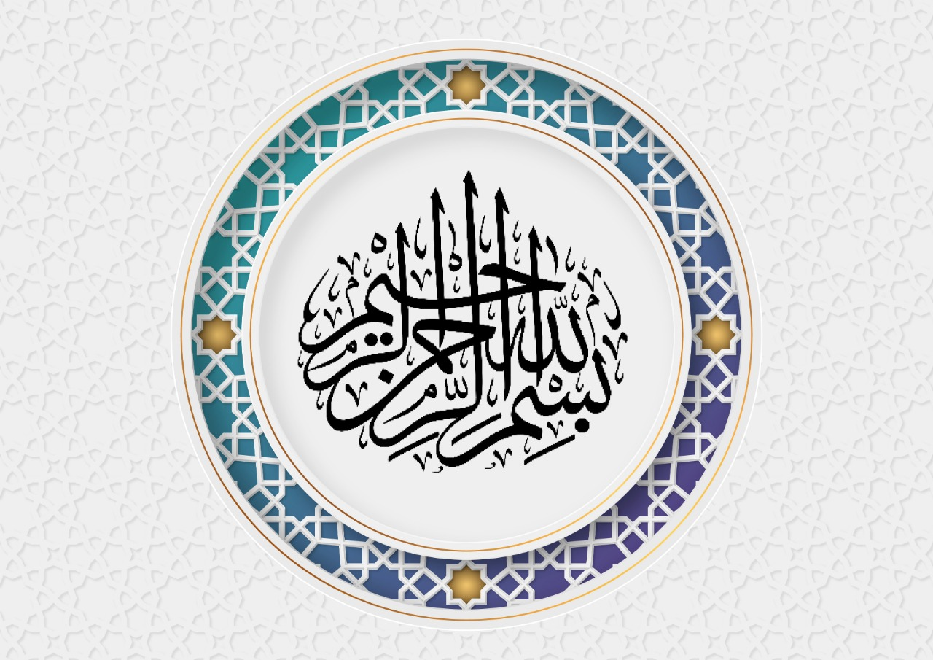

Table Of content:
Dean's word: ………………………………………………………………………………………………………………………………………………………………………………………………………………………………………………………………………………………………….. 4
Thanks and appreciation report …………………………………………………………………………..…………………………………………………………………………………………………………………………………………………..……………… 5
Objectives of the report …………………………………………………………………………………………………………………………………………………………………………………………………………………………………………………………………… 6
Introduction to the College of Education - Al-Kharj ……………………………………………………………………………………………………………………………………………………………………………………….… 7
About the college: ………………………………………………………………………………………………………………………………………………………………………………………………………………………………………………………………….……………… 7
Visibility: …………………………………………………………………………………………………………………………………………………………………………………………………………………………………………………………………………………………………………… 7
Message: ………………………………………………………………………………………………………………………………………………………………….……………………………………………………………………………………………………………………………………… 7
Core Values: ………………………………………………………………………………………………………………………………………….……………………………………………………………………………………………………………………………………………………… 7
Strategic Objectives: …………………………………………………………………………………………………………………………………………………………………………………………………………………………………………………………………………… 9
Organizational Structure: ………………………………………………………………………………………………………………………………………………………………………………………………………………………………………………………….…… 12
Academic departments and academic programs: ……………………..………………………………………………………………………………………………………………………………………………………………….…… 13
Administration: …………………………………………………………………………………………………………………………………………………………………………………………………………………………………………………………………………………….…… 14
College Board: ……………………………………………………………………………………………………………………………………………………………………………………………………………………………………………………………………………………….…… 15
College Board Topics: ……………………………………………………………………………………………………………………………………..……………………………………………………………………………………………………………………….….……… 15
Supporting college units and committees: ……………………………………………………………………………………………..…………………………………………………………………………………………………….….………… 17
Faculty and staff: ……………………………………………………………………………………………………………………………………………………………………………………………………………………………………………………………………….….………… 20
Faculty members: …………………………………………………………………………………………………………………………………………………………………………………………………………………………………………………………………….….………… 20
Statistics of male and female employees: ………………………………………………………………………………………….…………………………………………………………………………………………………………….…….…… 23
Scholarship: …………………………………………………………………………………………………………………………………………………………………….……………………………………………………………………………………………………………………….…… 25
Scholarships by academic departments: ……………………………………………………………………………………………………………………………………………………………………………………………………………………… 25
Scholarships by degree: ………………………………………………………………………………………………………….…………………………………………………………………………………………………………………………………………….………… 26
Scholarships by scholarship countries: …………………………………………………………………………………………………………………………………………….…………………………………………………………………….……… 27
Field training: ………………………………………………………………………………………………………………………………………………….………………………………………………………………………………………………………………………………….……… 28
Distribution of schools nominated to train female students: ………………………………………………………………………………………………………………………………………………………….…… 28
Statistics of field training students: ………………………………………………………………………………………………………………………….………………………………………………………………………………………………….…… 28
Qualifying lectures for field training students: …………………………………….………………………………………………………………………………………………………………………………………………………….…… 29
Educational and Academic Affairs: ……………………………………………………………………………………………..…………………………………………………………………………………………………………………………….……… 30
Number of students by gender and nationality: ……………………………………………………………………..………………………………………………………………………………………………………………….……… 30
Alumni: …………………………………………………………………………………………………………………………………………………………………………………………………………………………………………………………………………………………….……………… 33
3
Learning Resources: ……………………………………………………………………………………………………………………………….……………………………………………………………………………………………………………………………………… 35
Facilities and equipment: ……………………………………………………………………………………………………………………………………………………………………………………………………………………………………..………………… 37
Scientific conferences and symposia: ……………………………………………………………………………………..………………………………………………………………………………………………………………………………… 39
Training courses and workshops: ………………………………………………………………………………………………………………………………………………………………………………………………………………………………..… 40
Research papers, books and publications: …………………………………………………………………………………………………………………………………………………………………………………………………………… 41
Supervision and arbitration of scientific theses and scientific awards: ………………………………………………………………………………………………………………………………… 42
Development and Quality: ………………………………………………………………………………………………………………………………….………………………………………………………………………………………………………………… 43
Agency vision: ………………………………………………………………………………………………………………………………………………………..…………………………………………………………………………………………………………………………… 43
Agency message: …………………………………………………………………………………………………………………………………………………………………………………….…………………………………………….………………………………………… 43
Overall goal: ……………………………………………………………………………………………………………………………………………………………………………………………………………………………………………………………………..…………………… 43
Agency units: ……………………………………………………………………………………………………………………………………………………………………………………..………………………………………………………………………………………………… 43
The strategic objectives of the Agency for Development and Quality and the mechanisms for achieving them during the period from 1441 AH: ………………………………………………………………………………………………………………………………………………………………………………………………………………………………………………………………….……… 44
Development and Quality Agency Activities and Workshops: …………………………………………………………………………………………………………………………………………………..…… 45
Professional Development and Training: ……………………………………………………………………………………………………………………………………….……………………………………………………………………… 47
Community service: ……………………………………………………………………………………………………………………………………………………………………………………………………………………………………………………………………… 49
Student Activities and Events: …………………………………………………………………………………………………………………………………………………………………………………………………………………………………………… 51
Performance progression level: ……………………………………………………………………………………………………………………………………………………………………………………………………………………………………… 76
Obstacles to work: ………………………………………………………………………………………………………………………………………………………………………………………………………………………………………………………………………… 77
future ambitions: …………………………………………………………………………………………………………………………………………………………………………………………………………………………………………………………………………… 77
Activities in Pictures: ………………………………………………………………………………………………………………………………………………………………………………………………………………….…………………………………………………78
Communication with the college: ………………………………………………………………………………………………………………………………………………………………………………………………………………………………… 95
3

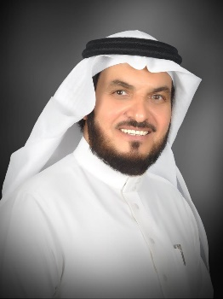
Dean's word:

In the name of God, the most gracious, the most merciful
And praise be to God, the Most High, the Great, who said: “And say work, so God will see your work,
and His Messenger and the believers.”
The Deanship of the College of Education in Al-Kharj is pleased and honored to put in your hands the annual
report of the work accomplished in the academic year 1441 AH, in pages that represent an effort made by a
team of the faculty’s employees that included individuals from the scientific departments and administrative units
as well as the technical units in the college. They worked in a team spirit and faithfully and transparently monitored the scientific, cultural and social activities in the college, and what was presented in the service of the community. These efforts were affected by the Corona pandemic in the second semester, whose secrets were overcome by relying on virtual activities and meetings, and the report came full of statistics that chart a number of achievements, goals and details It was also accompanied and supported by graphs and pictures that approximate the picture and summarize the information, and the report in its general form was extracted from the strategic plan of the college, and its paragraphs accompanies the university’s plan and strategic objectives, and thanks for that after God Almighty is extended to His Excellency the President of the University for his follow-up to the college’s activities and all its programs, and for his directives And his valuable observations and observations, and thanks to the Agency for Graduate Studies, Scientific Research, Quality and Community Service for the effort expended in preparing and producing the pages of this report, as well as thanks to all the college’s vice-deans, heads of scientific departments, heads of administrative units, student activity unit, and all student clubs. Appreciation, and God bless you in the beginning and in the end.

Dean of the College

Dr. Abdul Rahman bin Obaid Al-Rafdi

4

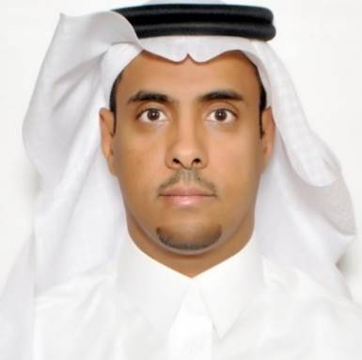
Thanks and appreciation

Praise be to God, and prayers and peace be upon the most honorable of the messengers and the seal of the prophets, Muhammad, may God’s prayers and peace be upon him, and after
We are honored to put in your hands the annual report of the College of Education for the academic year 1441 AH, which highlights the goals that have been achieved. During a year in which the Corona pandemic shook the world, but it was a year that was characterized by seriousness, diligence, and diligent and organized team work in all departments, units and various committees; What led to positive results in many areas will be mentioned in the details of this report. This report includes many statistics in various fields, as well as monitors the various scientific, cultural and social activities, and the service of the college and society.
We at the college strive for continuous development and improvement every year, God willing; To achieve our ambition and that of the leadership of this college to be compatible and in line with the strategic plan of the university, Vision 2030 and the National Transformation Program, God willing.
Finally, we extend our sincere thanks to His Excellency the Dean of the College of Education, Dr. Abdul Rahman bin Obaid Al-Rafdi, may God preserve him, for his support and follow-up, and thanks are extended to the heads and deputies of departments, faculty members, staff and students who contributed to the success of the college.
And all thanks to the work team who prepared this report and everyone who participated in its preparation and its distinguished production.
We ask God to make us from those who do good and master it.

Vice Dean for Graduate Studies, Scientific Research,
Quality and Community Service

Dr.Mubarak bin Saad Al-Wuzrah

5

Report Objectives
This report aims to:
1- Monitoring the college's achievements in an entire academic year.
2- A statement of the level of progress in the work.
3- Determine the strengths or weaknesses in the performance path.
4- Recording the obstacles that stood in the way of achievement.
5- A statement of the plan to address the obstacles.
6- Draw the future ambitions of the college.

Introduction to the College of Education - Al-Kharj
6

About the college:
The College of Education for Girls was established in Al-Kharj Governorate in the year 1403 AH and it was awarded a diploma degree only. On 11/29/1414 AH, the General President of Girls’ Education issued Decision No. 1597/1 to develop the Intermediate College in Al-Kharj as of the academic year 1415/1416 AH into a College of Education according to the four-year system, where the student is awarded a bachelor’s degree by virtue of the decision.
In the year 1417/1418 AH, the scientific departments were separated into a separate building located in the east of the governorate - Al-Faisaliah – and in the year 1422/1423 AH a new department was opened in the college due to the governorate’s need to specialize in history.
In the year 1423/1424 AH, the approval of His Excellency the Deputy Minister of Education for Girls' Education Affairs was issued to open the door for admission to affiliation with girls' colleges in the Kingdom to provide the opportunity to accept the largest possible number of female students.
In the year 1429/1430 AH the college joined King Saud University, and in the year 1431 AH the college joined the University of Al-Kharj, whose name was changed to Salman bin Abdulaziz University. Then, by royal order, the name was changed to Prince Sattam bin Abdulaziz University.

Vision:
A distinguished faculty in education, educational research, community partnerships, and competition in the labor market.

The Message::
Providing distinguished educational education, developing innovative educational research, and enhancing community partnership through a stimulating academic environment and distinguished human and technical resources.

Core Values:
The Executive Committee of the strategic plan of the College of Education has derived a chairwoman drawn from the guidance of the true Islam. These values ​​form the basis on which the college is based in its academic and administrative performance, and it is the framework that governs the ethics of dealing between the faculty members, administrators and students.
7
The values ​​adopted by the College of Education in Al-Kharj are also derived from the values ​​and objectives of Prince Sattam bin Abdul-Aziz University, which are national identity, justice, team spirit, perfection, transparency and responsibility. The following is a definition of each of these values:
National identity: commitment to the values ​​of belonging and citizenship.
Justice: Treating all college employees with the same standard without favoritism or discrimination.
Team spirit: Encouraging team spirit to accomplish goals.
Perfection: Observing God, adhering to quality standards, and continuous development.
Responsibility: Encouraging the bearing of burdens and individual and societal responsibility.
Transparency: Being honest in publishing documents and reports and being ready to answer inquiries about them at all times.

Strategic Goals:
8
- Strengthening the mental image of the college locally and regionally.
- Enabling the graduate to compete in the labor market.
- Develop teaching and learning strategies in the college.
- Development of human resources in the college and the development of its skills.
- Developing postgraduate programs.
- Improving quality practices and their applications in the college.
- Develop programs that support social responsibility and build effective community partnerships.
9

